

**Graded Lab Assignment 1 – CSF416_Web Technologies and Applications, ODD Sem, 2024**

**Student Name: Sanjay Kumar Mandal**

**ID: 1000015812**

**Major: B.tech IT**

**Instructions**

* There are **2** questions in this assignment.
* Email/paper/other modes of submissions will not be accepted.
* Upload a word **version** of this document.
* Assignment submitted after due date will not be evaluated and a score of zero will be awarded.
* Plagiarism may lead to award of zero marks.

**Due Date: 12pm, 4th Sept. 2024**

**Submitting this Assignment**

You will submit (upload) this assignment in MS Teams. Name this document as GLA1_AJPODD2024_John_Doe.doc in case your name is John Doe, and this graded lab assignment is 1 of course whose acronym is AJP, and offered in ODD 2024. Paste your code after each question, paste the screenshot of output, save and upload the document.

**Grading Scheme:** This assignment has5 marks.

**Question 1:**

Create a web page for internal links; when the user clicks on different links on the web page it should go to the appropriate locations/sections in the same page.

**CODES-**

<!DOCTYPE html>

<html lang="en">

<head>

<meta charset="UTF-8">

<meta name="viewport" content="width=device-width, initial-scale=1.0">

<title>Internal Links Example</title>

<style>

body {

font-family: Arial, sans-serif;

margin: 20px;

}

section {

margin-top: 50px;

}

nav a {

margin-right: 15px;

text-decoration: none;

color: blue;

}

nav a:hover {

text-decoration: underline;

}

</style>

</head>

<body>

<h1>Internal Links Example</h1>

<nav>

<a href="#section1">Go to Section 1</a>

<a href="#section2">Go to Section 2</a>

<a href="#section3">Go to Section 3</a>

</nav>

<section id="section1">

<h2>Section 1</h2>

<p>This is the content of Section 1. Lorem ipsum dolor sit amet, consectetur adipiscing elit.</p>

</section>

<section id="section2">

<h2>Section 2</h2>

<p>This is the content of Section 2. Vestibulum ante ipsum primis in faucibus orci luctus et ultrices posuere cubilia curae.</p>

</section>

<section id="section3">

<h2>Section 3</h2>

<p>This is the content of Section 3. Nullam dictum felis eu pede mollis pretium. Integer tincidunt.</p>

</section>

</body>

</html>

**OUTPUT**

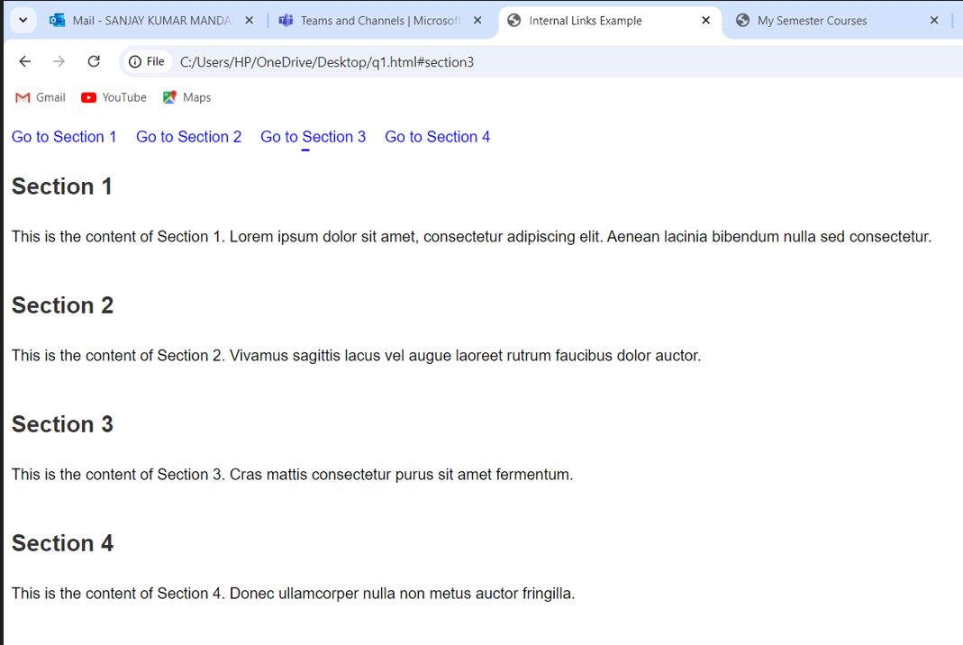

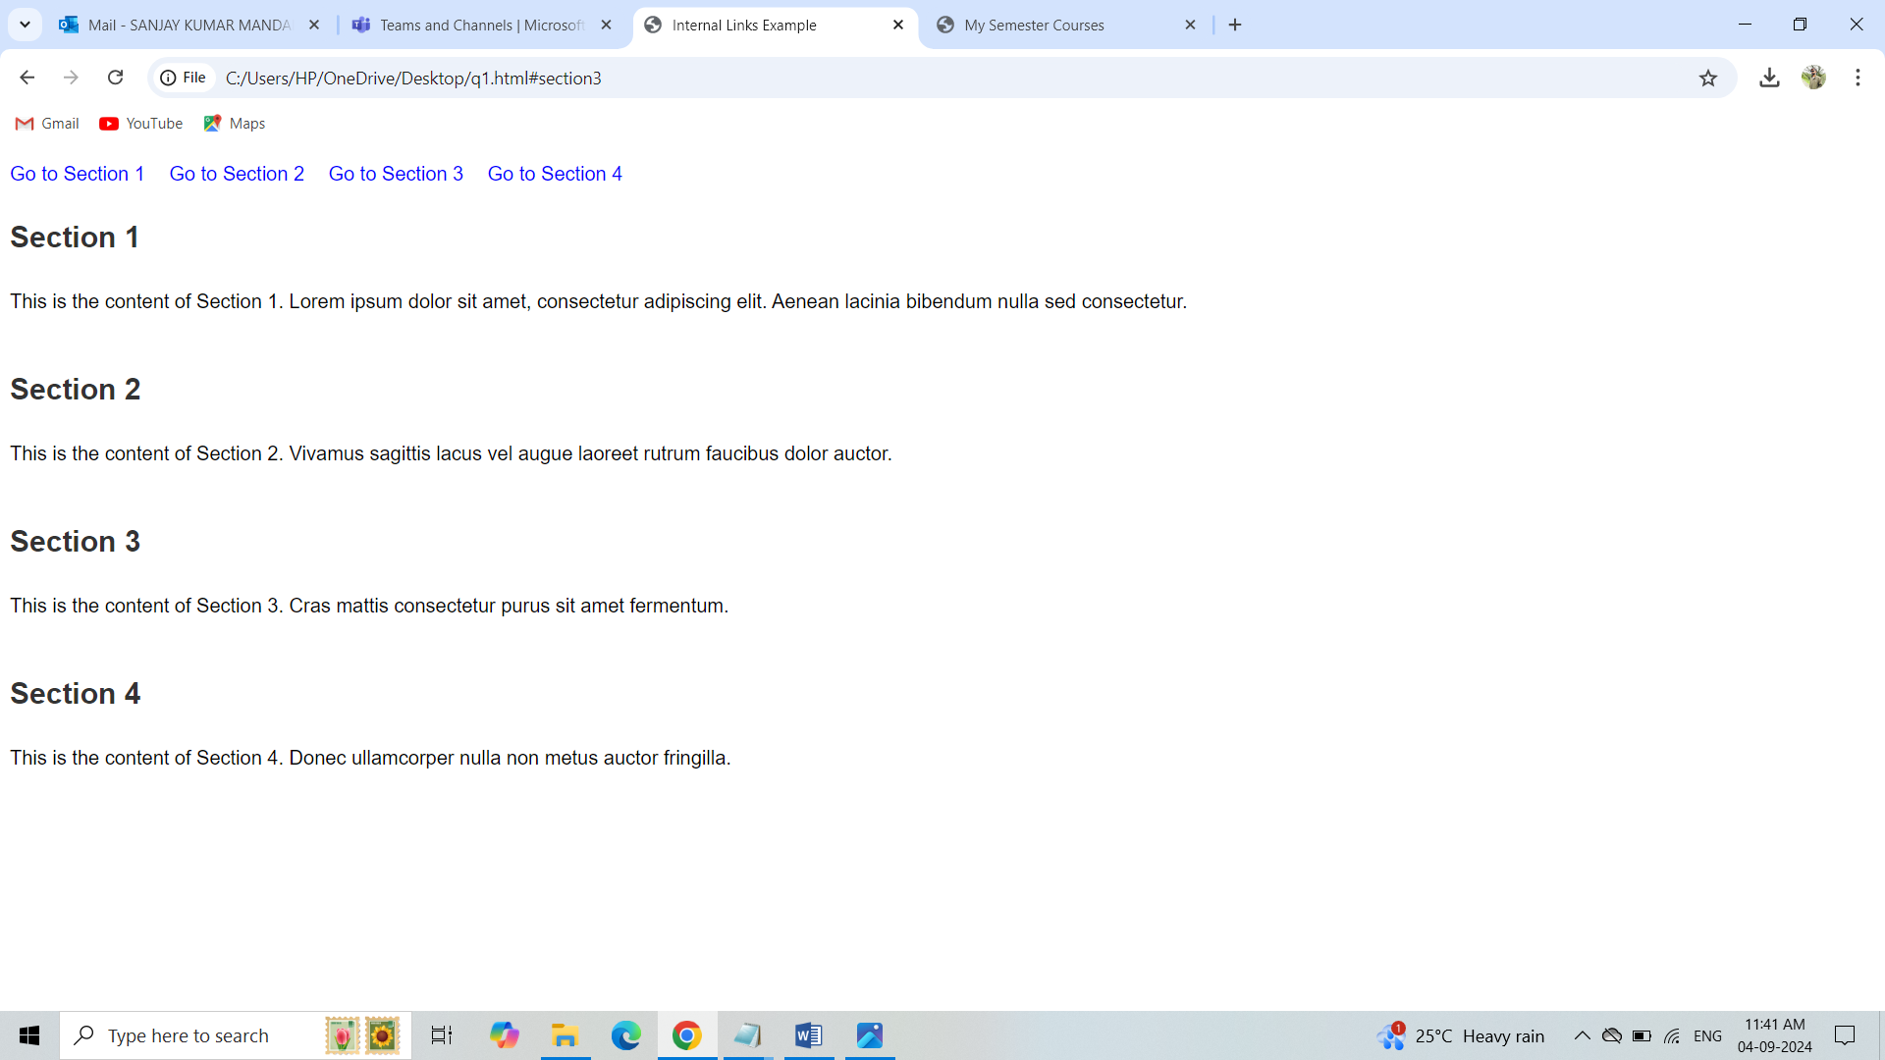

**Question 2:**

Create a web page, showing an ordered list of all semester courses enrolled.

**CODES-**

<!DOCTYPE html>

<html lang="en">

<head>

<meta charset="UTF-8">

<meta name="viewport" content="width=device-width, initial-scale=1.0">

<title>My Semester Courses</title>

<style>

body {

font-family: Arial, sans-serif;

margin: 20px;

background-color: #f4f4f4;

color: #333;

}

h1 {

color: #0056b3;

}

ol {

background-color: #fff;

padding: 20px;

border-radius: 5px;

box-shadow: 0 0 10px rgba(0, 0, 0, 0.1);

}

li {

margin: 10px 0;

}

</style>

</head>

<body>

<h1>My Semester Courses</h1>

<ol>

<li>Web Technologies and Applications</li>

<li>Data Structures and Algorithms</li>

<li>Discrete Mathematics</li>

<li>Operating Systems</li>

<li>Database Management Systems</li>

<li>Software Engineering</li>

<li>Computer Networks</li>

</ol>

</body>

</html>

**OUTPUT**

